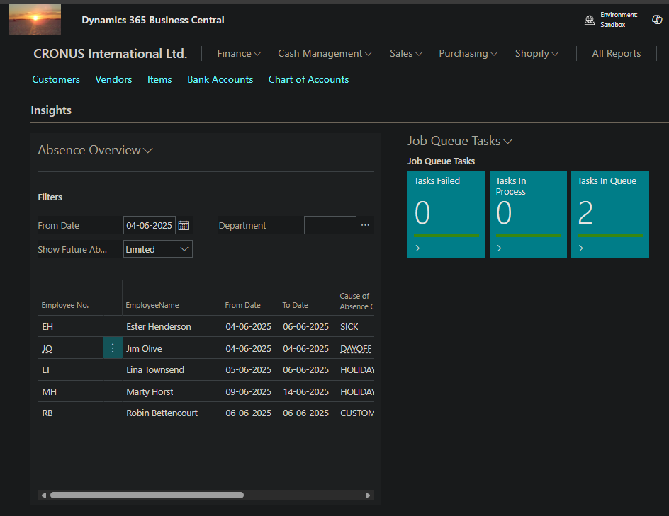

Absence Registration Overview
Not too long ago, I was part of a major upgrade from BC14 to Business Central in the cloud. Actually, the solution was way older than BC14 and had been upgraded many times and ended – as so many other Navision solutions – to impossible to upgrade.
Since the whole solution had been scrapped and only essential customizations were transferred to the new core app. One of the customizations that had been omitted were the Absence Registration and the Absence Registration Overview. I was then asked if I could facilitate make a solution like that because it was imperative that the employees could get an overview of, who were present at the office today, who were at customers and who were absent due to sickness or holiday.
My first comment was: “Why not use the standard Absence Registration” module in the Base Application. After a quick glance, the standard Absence Registration was actually 99% the same as the customization that they had previously.
The only thing missing was the Absence Registration Overview that was situated in the role centers.
Therefore, I made a solution for them to view the Absence Registration on their Role Center. That is such a good idea that I asked for permission to give the app away as an another open-source app.
So, this is it:

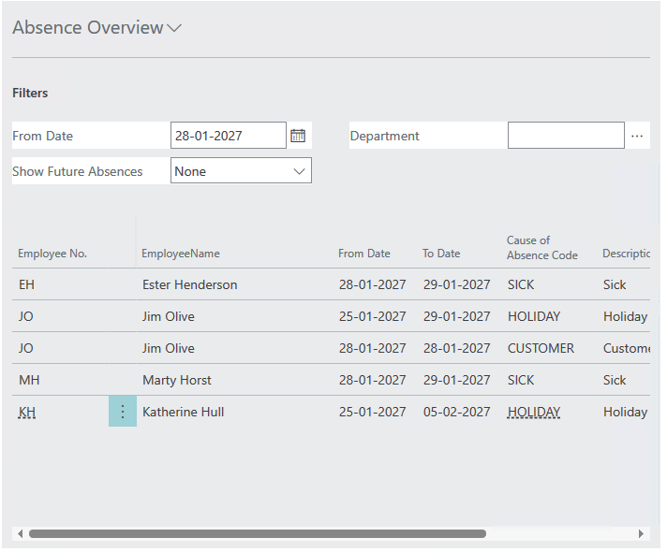
And of course, the further I got, the more complex it became:
The Overview can show:
- Who is not present at the office today?
- Who will be gone in the near future (limited)?
- And future planned absences
Also, having large organizations, it must be possible to filter to show only employees that are relevant to me.
This is done by assigning a finance dimension to be the “Employee Group Filter” in this case the Department dimension has been selected, but it is possible to create a new dimension only employee filtering purposes.
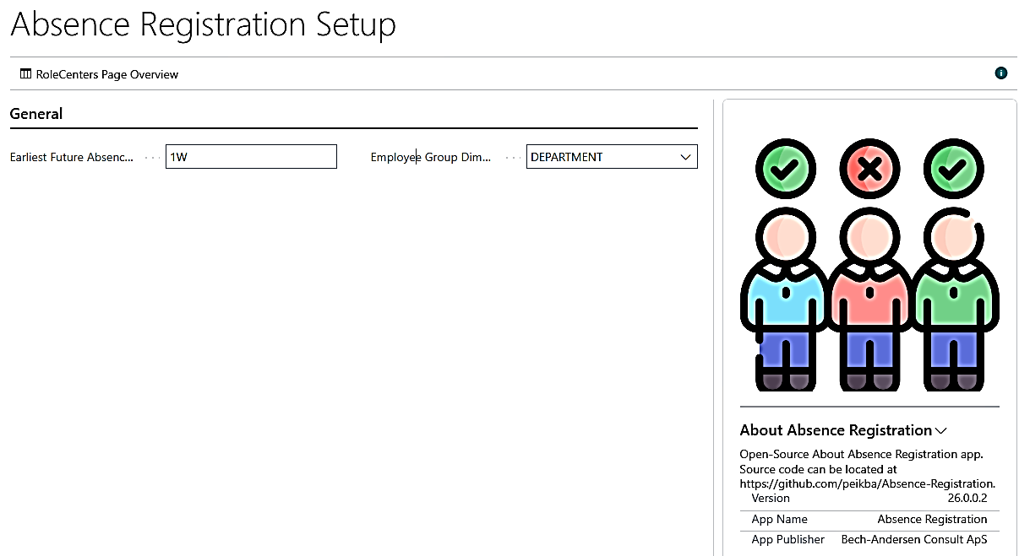
In order to preset, which Employee Grous that are relevant for this user, I have linked the filter to any of the Responsibility centers:
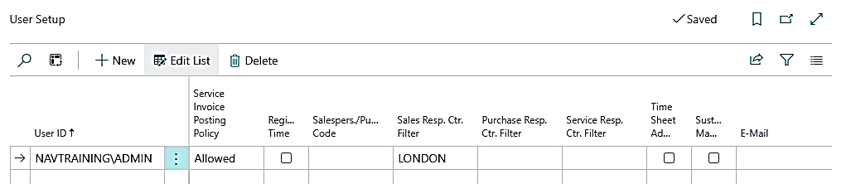
And if the finance dimension has been set on the Responsibility Center:
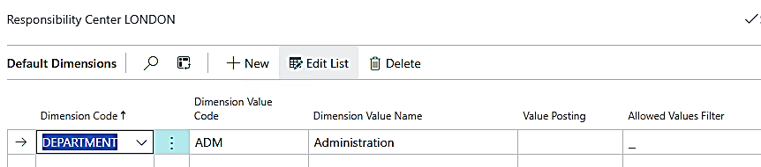
It will automatically be defaulted on the Absence Registration Overview:
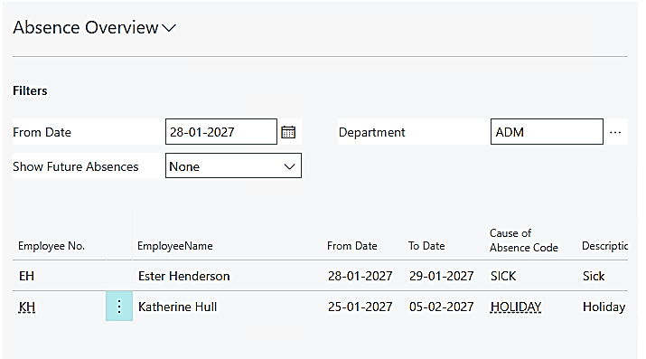
As always, the solution resides in my Github account and it can be downloaded from here:
peikba/Absence-Registration
Have fun with that.


